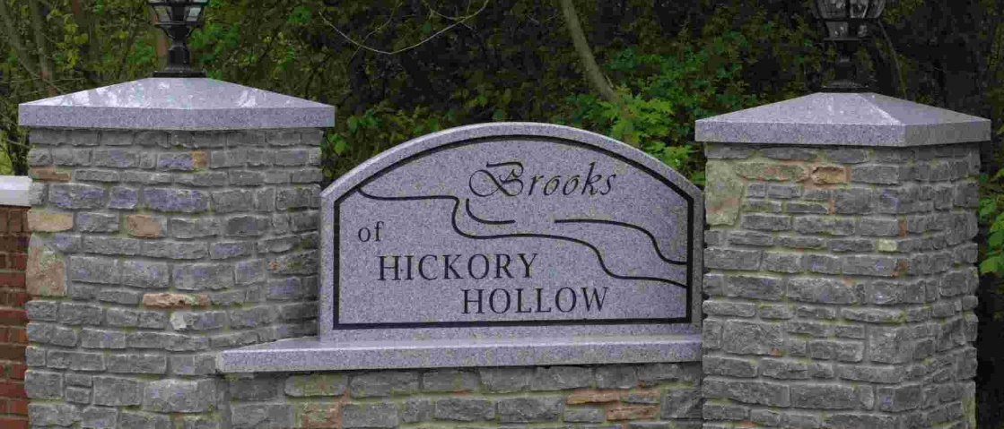
Spring
2026
in this issue >>>

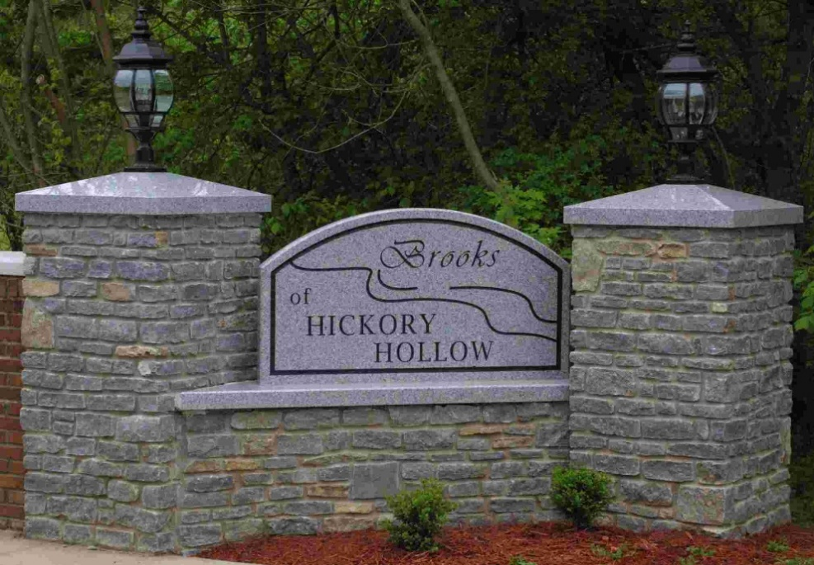

Snow Removal
Annual Dues
Trash Service
Contact Information
Community Rules
Good news! Louisville Metro now pre-treats and removes snow on Shenandoah Drive from Chamberlain Lane to Shady Hollow Drive.
However, major roads are done before residential streets like Shenandoah. Since we have a special agreement with our BHHCA contractor to be the first customer they service, he will continue to do Shenandoah in case Louisville Metro doesn’t get out right away. With our contractor and Louisville Metro both doing snow removal, Shenandoah Drive should be in good shape when it snows.
Contact Information:
Pothole or Sidewalk Repair:
Homeowners can contact Louisville Metro Call – online at http://louisville.gov/government/metrocall-311 or call 311 to request a repair.

Street Light Out:
Call LG&E at 589-1444 and provide the address of the home closest to the light. We pay a flat rate per light, whether the light works or not, and repairs are included. Any homeowner can request a repair.

Verify Annual Dues:
If a closing agent needs to verify dues have been paid, please email Ken Wheat at kwheat97@aol.com.

Questions, Complaints, or Concerns:
Email the Board of Directors at bhhcaboard@gmail.com. Please provide the property address and specific details.

Trash Service:
Homeowners pay for trash collection directly to the company they choose. BHHCA does have special community rates with Republic Services. Homeowners can call Republic at 502-638-9000 for service. They also have recycling and yard waste as optional services. Please promptly store trash cans out of sight from the street after collection.

Annual Dues:
Annual dues pay for snow removal, landscape maintenance, LG&E street lights, front entrance lights and sprinklers, website, accounting/operating expenses, etc.

A huge thank you to the Brooks of Hickory Hollow community! While we typically enjoy a fantastic 99% collection rate, we are thrilled to share that 2025 was a record-breaking year with 100% of our 240 households paying their annual dues.

Because of this full participation and the Board’s ongoing commitment to keeping expenses as low as possible, we are happy to announce that 2026 annual dues will remain the same as 2025 with no increase. And the last increase was 4 years ago! We truly appreciate your support in keeping our neighborhood a wonderful place to live!

Dues must be paid by April 30 with a discount for paying early by March 31 and late fee after April 30. Let’s make it 100% again for 2026!

• Community Yard Sale
– Saturday, June 6 (First Saturday in June)
• Annual Meeting
– August (Date to be determined.)
Events:
current topics >>>
Snow Removal:
Brooks of Hickory Hollow Community Association, Inc. Newsletter
Community Rules
All homeowners and tenants must comply with BHHCA rules. The Board of Directors does not police the community looking for violations. We rely on neighbors to bring their concerns to the Board’s attention. All complaints are kept confidential. The Declaration of Covenants, Conditions, & Restrictions can be found on the website and in the public records of Jefferson County.
Yard Maintenance: Lots must be kept in a neat and attractive manner. This includes trimming grass/weeds behind fences and all ditch and easement areas adjacent to each property.

Rentals: Homes are for private single-family residential purposes. No boarding/lodging houses, hotels, etc. are allowed. For example, homes can’t be rented as Airbnb or similar short-term rentals.

Street Parking & Towing: Vehicles are to be kept in the garage or driveway. Street parking is limited to 10 continuous hours and no more than 24 hours in a calendar year. When a violation is reported, a sticker is placed on the vehicle and letter mailed to the homeowner. Continued violations will result in the vehicle being towed at owner’s expense. The tow company BHHCA uses is Derby City Towing of Louisville located at 2800 Millers Lane, Louisville, KY 40216. Please note: It is also a violation of BHHCA restrictions and Jefferson County Ordinance to block the sidewalk or park in the grass.

RV’s, Boats, & Trailers: No bus, mobile home, motor home, trailer, truck, motorcycle, commercial vehicle, camper trailer, camping unit, camping vehicle or boat shall be parked or kept on any Lot at any time unless housed in a closed garage.

Chain Link Fences: No new chain link fences are allowed under any circumstances and existing ones cannot be replaced.

Above-ground pools: In-ground pools, hot tubs, or spas are allowed if the size, design, placement and landscaping are approved in writing by the Board. Above-ground pools are not allowed.

Basketball goals: Basketball goals are allowed if not visible from any road. In other words, keep it in the backyard.
P.O. Box 436266
Louisville, KY 40253
Email: bhhcaboard@gmail.com
Website: www.bhhca.org
Facebook: www.facebook.com/bhhca

Community Association, Inc.
Brooks of Hickory Hollow

The Board occasionally emails important updates concerning our community. If you are not receiving BHHCA emails, please send your property address and email to bhhcaboard@gmail.com.

Kathy Wright, President
Tony Newell, Vice President
David Phillips, Secretary
Don Coffey
Scottie Walker
BHHCA Board of Directors:

Finding An Agent That’s Right For You
thoughts...
final

